Predicting Community Illness

Team Lead: Joshua
Recorder & Spokesperson: Derrick Toussaint

Recap: Background & Question:

To what extent can demographic and civil variables—such as median income, population density, education level, and access to medical care—predict the prevalence of medical illness across different ZIP codes in Massachusetts?

Hypothesis & Prediction:
We hypothesize that Massachusetts ZIP codes with lower income, lower education attainment, higher population density, and less access to healthcare will show higher illness prevalence. We predict that these demographic factors will be statistically significant predictors of our engineered variable, illness_risk (categorized as Very High, High, Medium, and Low).

Methods:
We used the 2019 Social Determinants of Health (SDOH) dataset published by the Agency for Healthcare Research and Quality (AHRQ), provided by Professor Chris Healey. The dataset is in Excel format (.xlsx) and contains community-level indicators for ZIP codes across Massachusetts, including demographics, socioeconomic measures, education, healthcare access, and health outcomes.
We will conduct our analysis in Visual Studio Code usiing a python environment. VS Code allows integrated source control (Git), modular Python scripting, and Markdown documentation — ideal for collaborative data analysis. From there we will filter the data by Massachusetts zip codes to determine the outcomes based off the selected variables we choose. The dataset was filtered to Massachusetts ZIP codes and subsetted to include variables related to income, education, healthcare access, insurance, and illness indicators. The team engineered a composite feature illness_risk, combining multiple chronic illness frequencies into a four-tier variable: Very High, High, Medium, and Low

Results: 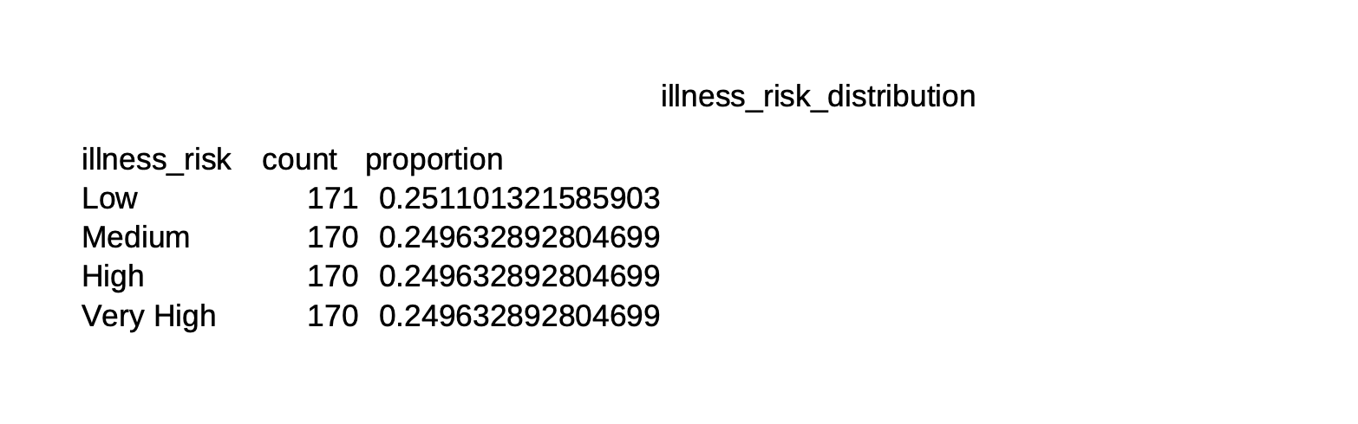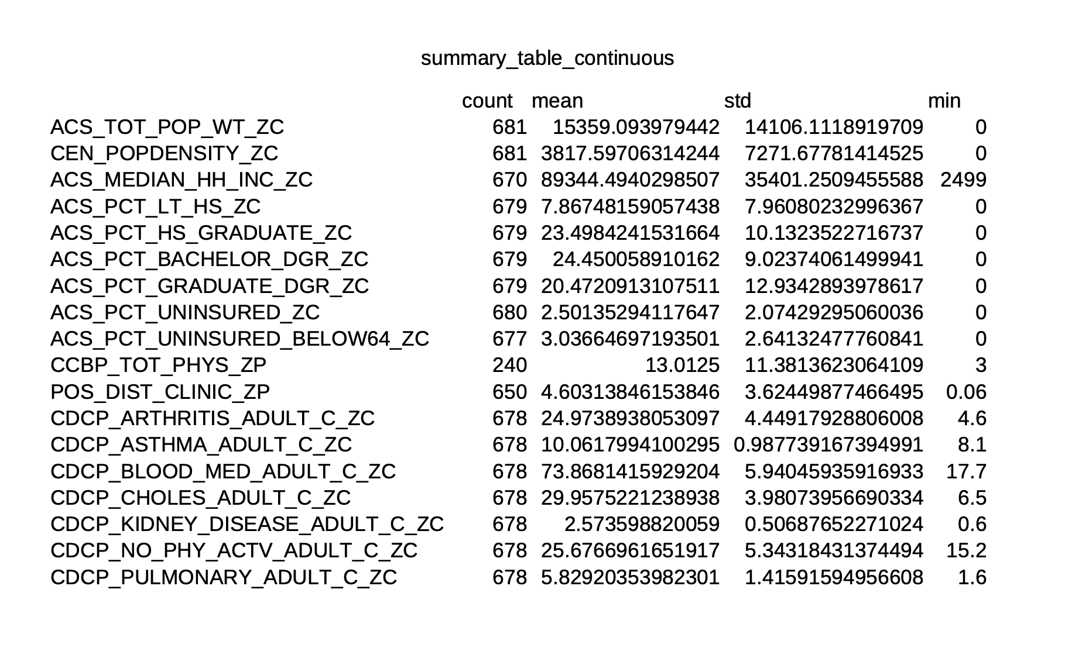
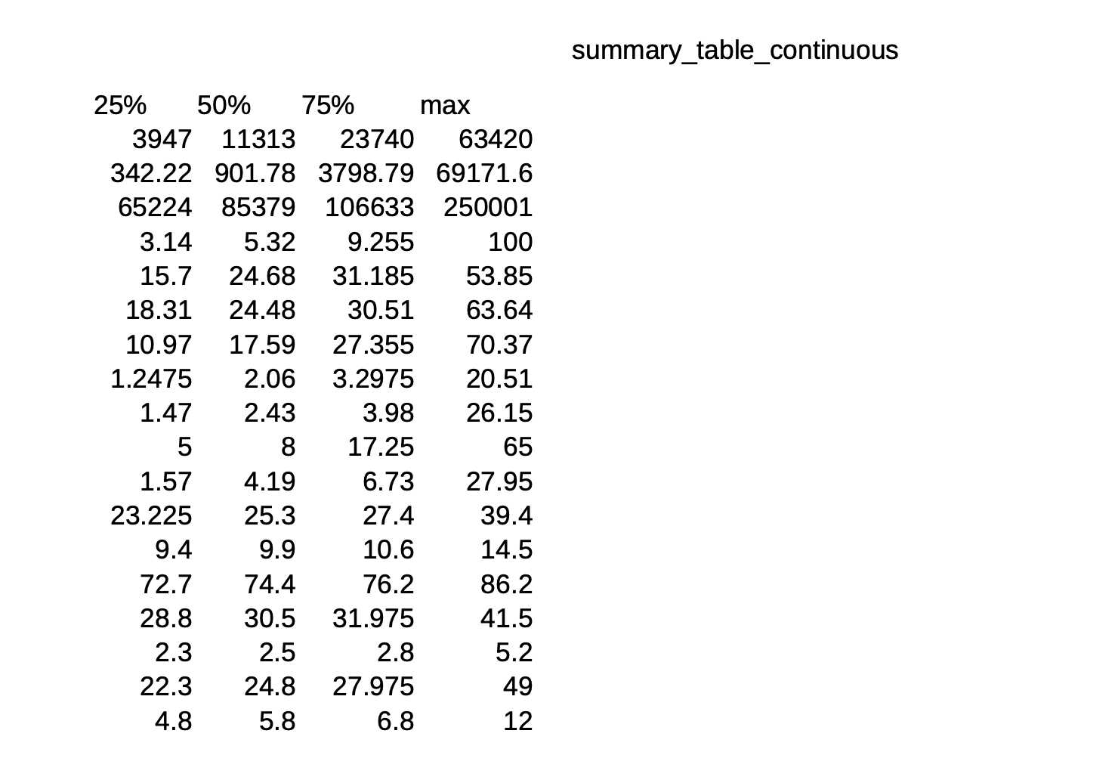
Descriptive statistics for the selected socioeconomic, demographic, and health-related variables revealed substantial variation across Massachusetts ZIP codes, particularly in income, insurance coverage, education levels, and chronic illness prevalence. Table 2 summarizes these continuous variables and highlights the broad ranges and uneven distributions suggesting meaningful differences in community health conditions. Table 3 shows the distribution of the engineered illness_risk categories, indicating that illness burden is not evenly spread across ZIP codes and that certain communities are more concentrated in higher-risk groups.

Discussion & Next Steps:
Moving forward, our next steps include completing data cleaning and preprocessing procedures such as handling missing values, normalizing or scaling continuous predictors, and potentially reducing redundant variables through correlation filtering or dimensionality reduction. We will also finalize our feature set by determining which socioeconomic and health access variables offer the strongest predictive signal for illness_risk.

